|  |  |
| --- | --- |
| **Q-ACSM NRT Export Tool v.4.3.9** | ACMCC |

Date : 07/05/2024

Version : v.4.3.9

Prepared by : Jean-Eudes Petit

**Requirements**

* ACSM DAQ should be open and ready to start. It is preferable to stop measurements when Installing / Updating / Configuring the export tool
* Igor should be open, acsm_local ipf configured, and existing data already loaded
* Correct IE & RIE values need to be set, as well as CE values (0.5 for standard vaporizer, 1 for capture vaporizer)
*  **TimeSeries and Ion Transmission corrections** needs to be configured and applied (and corresponding checkboxes checked)

Table of Content

2 Installation 3

3 Update 3

4 Configuration 4

5 Save / Load settings 7

6 Recreate Text Files for previous data 8

7 Realise Notes 9

# Installation

To load the ipf procedure within Igor, the user can:

* Place the file in the Igor Procedure folder (usually into Documents/WaveMetrics/Igor Pro 6/Igor Procedure), to be automatically loaded at the startup of Igor
* Double click on the file
* Drag and Drop the file into Igor

# Update

In case of updating the ipf, please follow the following steps :

* Stop measurements in DAQ
* For v.4.3.9 or higher:
  + Go to ACMCC Q-ACSM Export -> Update ipf. This will close the Export panel, and delete the ACMCC_Export folder in the Data Browser
* For earlier versions:
  + Close Export Panel if open (or execute in the command window KillWindow ExportPanel)
  + Delete ACMCC_Export folder in the data browser: Right-click on the folder and select Delete object(s), or execute KillDataFolder/Z root:ACMCC_Export in the command window
* Go to Windows -> Windows Procedure -> select ACMCC procedure (name can vary). This will open the code. Close the window, and select Kill
* Delete the old ipf file on the computer
* Follow the steps from Installation

# Configuration

If the procedure is correctly loaded and compiled, a menu “ACMCC Q-ACSM Export” should appear on the Igor menu bar.

To initialize the panel, click on ACMCC Q-ACSM Export -> Initialize Panel

For version 4.3.3. or higher : a message pops up to inform on which frag table is loaded on Igor.

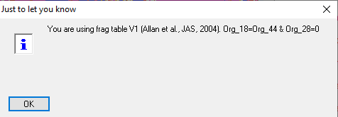

The panel is build subsequently:

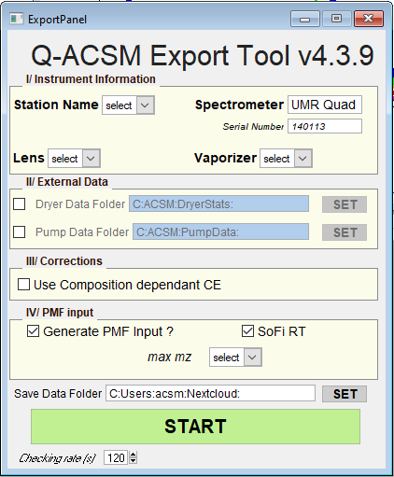

*Instrument Information*

* Set station name : The drop down menu contains a list of different stations. If not present, select Other, and type the name. This variable is only indicative, it is not used for metadata, only for filenaming. It is however required to be consistent over time.
* Procedure automatically detects type of ACSM, based on folders present in the data browser. In the case of Q-ACSM, serial number is automatically detected from DAQ_Matrix.
* Lens & vaporizer type can be set using corresponding dropdown menus.

*External Data*

* Dryer data can be automatically loaded and added to the textfile by checking the box. The path to the folder containing the data can be set by clicking on the SET button. **This feature is compatible only with DryerStats software**



* Pump data can be automatically loaded and added to the textfile by checking the box. The path to the folder containing the data can be set by clicking on the SET button.

*Corrections*

* Composition-dependant CE correction can be applied on the data by checking the box. Note that when selecting “Standart Vap.”, the checkbox is automatically checked; for “Capture Vap.”, the checkbox is automatically unchecked and disabled, assuming a constant CE of 1.

*PMF Input*

* Checking “Generate PMF input” will generate an additionnal textfile containing OA m/z concentrations and uncertainties, ready for PMF.
* Checking “SoFi RT” will generate an additionnal daily Igor text file (.itx) in a specific subfolder (/SoFi/) containing OA m/z concentrations and uncertainties, ready for SoFiRT.
* Max mz is the maximum mz value for OA matrices. Can be either 100 or 120.

*Save Data Folder*

* The path to the folder where text files will be saved needs to be set. Click on SET button, and then browse in order to select the correct folder.  This path needs to be consistent with the setup of /actris_acsm_converter/src/cfg/product.cfg

When configuration is complete, the user can press “START” in order to launch the background export functions. Button turns red when started.

**From there, measurements can be started back.**

For version 4.3.8 or higher : When START is pressed for the first time, a notebook appears as below. It provides information on the export process as well as some warnings related to the status of the measurements (eg low Airbeam, low pressure etc) to make the user quickly aware that a maintenance is needed (or not). Note that the Notebook can be minimize, but not directly closed. Please use ACMCC Q-ACSM Export -> Kill NoteBook function to do so.

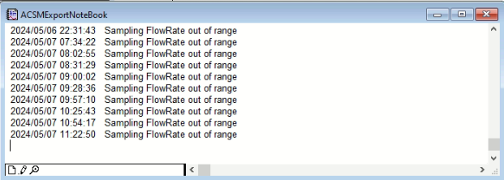

# Save / Load settings

For version v4.3.9 or higher

After completed the panel, the configuration can be saved to a textfile by clicking on ACMCC Q-ACSM Export -> Save Configuration

This will create a textfile in the Save Data Folder (where text files are saved).

Load the textfile is achieved by selecting ACMCC Q-ACSM Export -> Load Configuration from File. The file can be manually selected, and will automatically update all the parameters.

# Recreate Text Files for previous data

For version v4.3.7 or higher

It may happen that the export tool is not started, and that NRT data are missing. In this case NRT can be “simulated” by clicking on ACMCC Q-ACSM Export -> Recreate All Files. For all the data already loaded on the Igor experiment, export will be launched.

 It will overwrite existing files

 It is preferable to stop measurements from ACSM DAQ, because the process may take some time.

# Release Notes

v4.0.2 : first official release

v4.1 : bug correction on PMF input generation

v4.2 : SoFi RT

v4.2.2 : - CE export (forgot to do it before)

- check box variable bug (PMF & SoFi)

- correctly naming RT SoFi files (with station name & SN)

- extract org m/z only for SoFi

v4.2.3 : check for airbeam & RIT corrections before starting background task

v4.3: - Pump & Dryer data active

- error : quadratic sum replaced by regular sum

- added a check for wrong SN

- added max mz for org mx

- added checking rate variable

v4.3.1: mz28 in OrgMx for SoFi (forgotten before)

v4.3.2: CDCE correction for Orgmx (forgot to do it for SoFi, when a file already exists)

v4.3.3: check fragtable version in order to export the right org mx for PMF

v4.3.4: corrected bugs from ExportSoFi

v4.3.5: - corrected bugs from ExportSoFi. Compatibility with Igor7

- Changed names of 2 functions for dryer data, for AASQA procedure compatibility

v4.3.6: check for mzbool (sometimes the wave is not saved at the right place, when the acquisition is running)

v4.3.7: simulate export from previous data.

v4.3.8: - enabled pump data loading & exporting

- enabled dryer data loading & exporting

- NoteBook

- if CEdry=NaN, replaced by 0.5

v4.3.9: - Save Configuration in textfile

- Load Configuration from textfile